Async -Await

Await

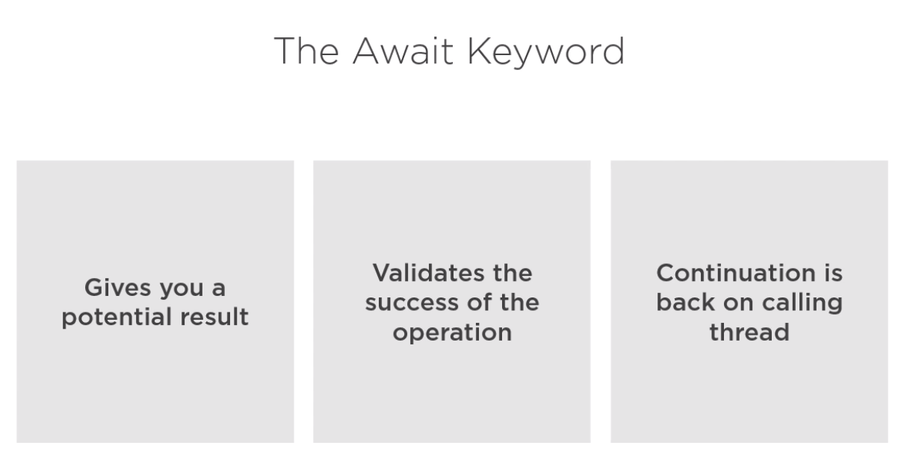

Continuation

The code execution after asynchronous operation complete the await

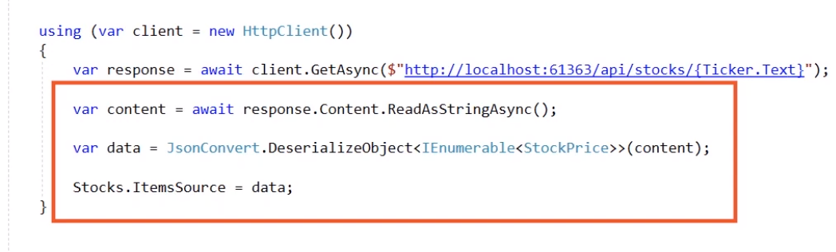





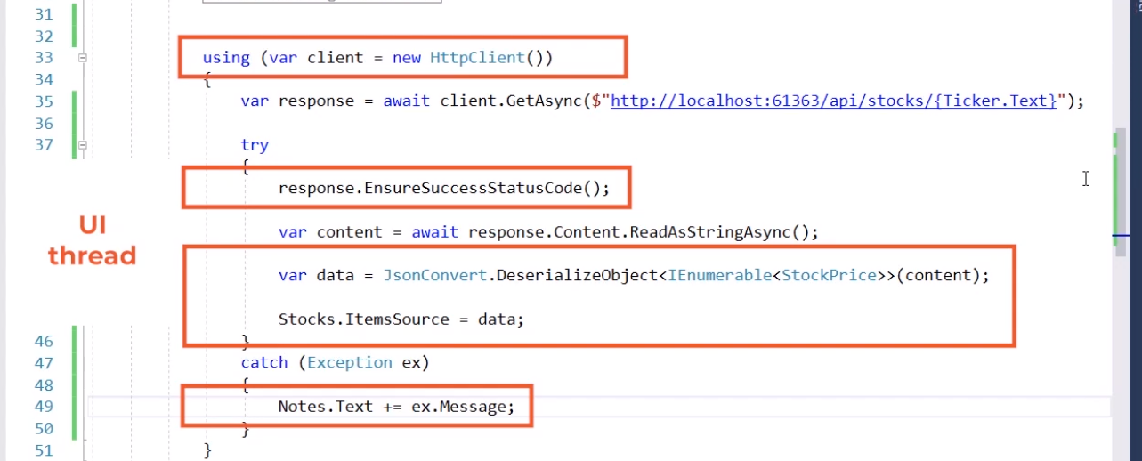

Async





It only use for event handler

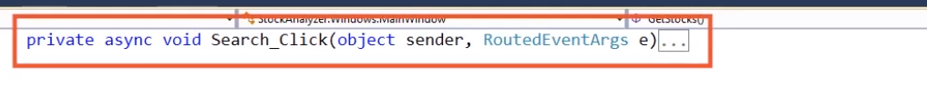



Return Task



Compiler generate the return

It getting a reference of ongoing task

BEST Practice

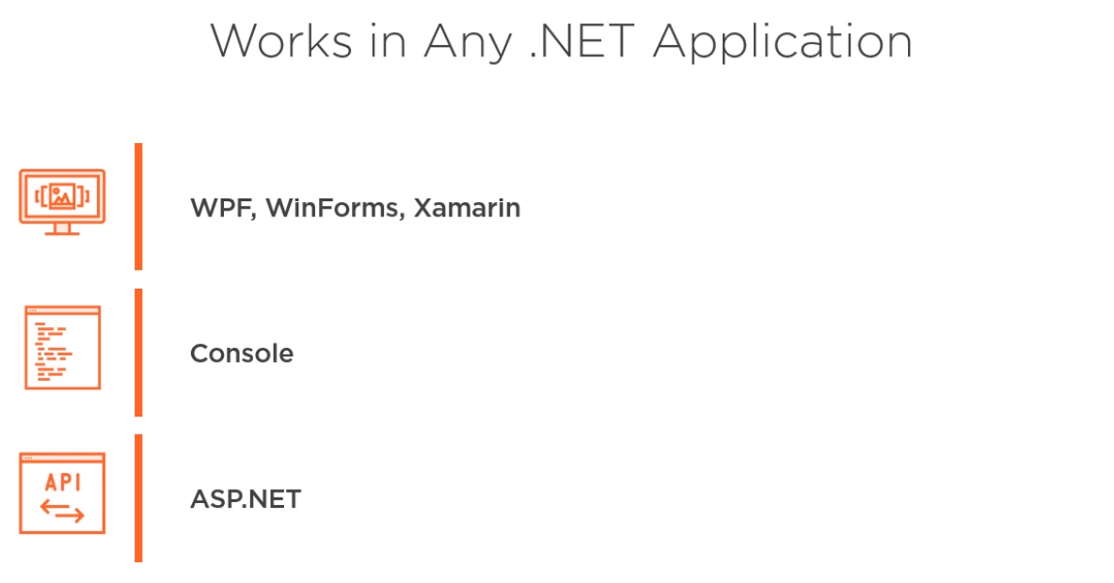



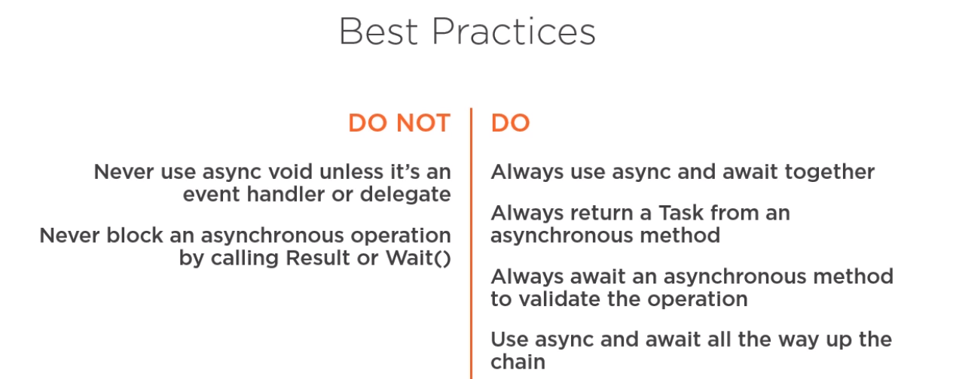

Using the Task Parallel Library in .NET

Task:



Use to schedule work one the asynchronies operation done and if there is problem it cancel or continue.



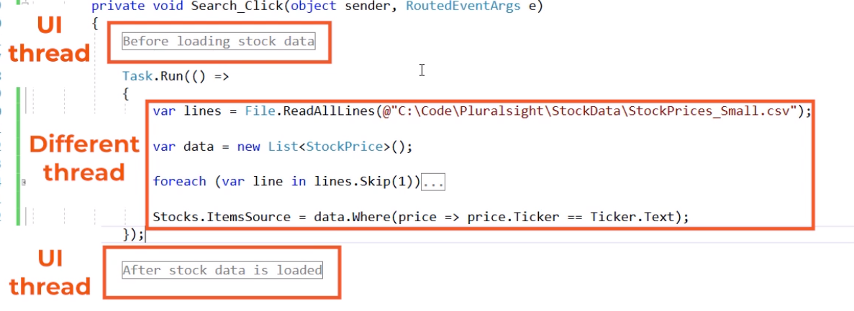

ACCESS recourse in different thread

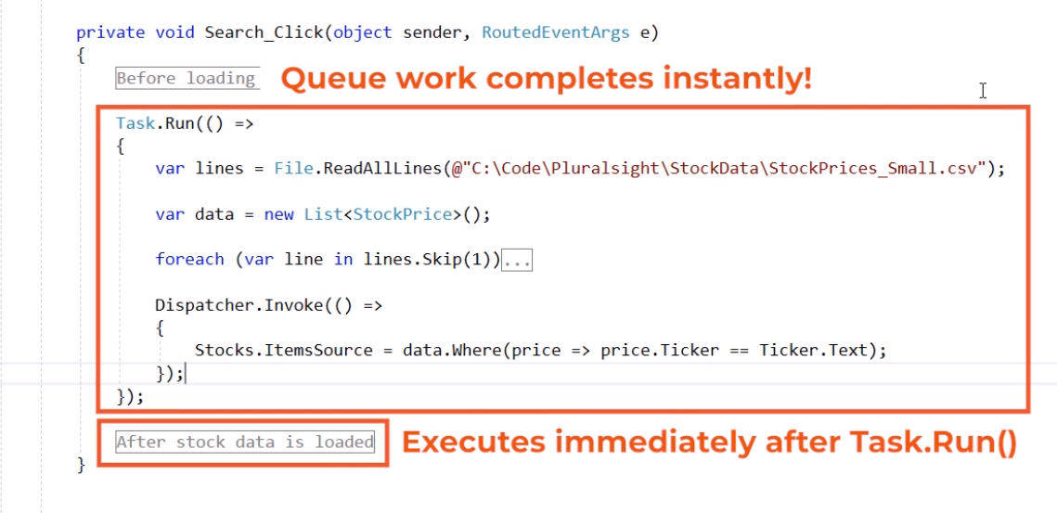

ContinueWith







Async & Await inside task

Can use async and await with task

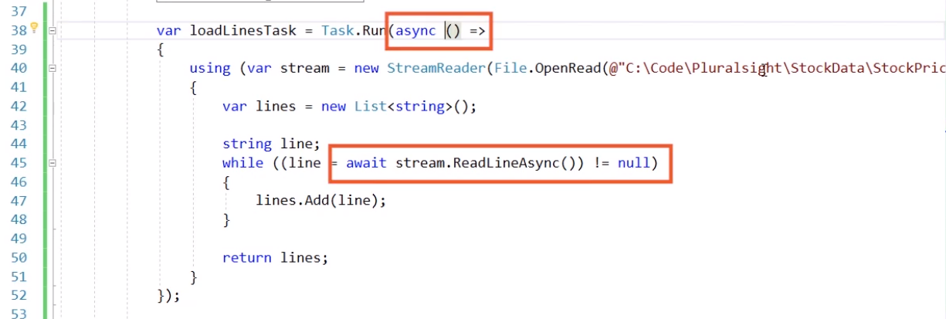

Error handle in Task & continueWith



Using TaskContinuationOptions we can chose when this contieation execute

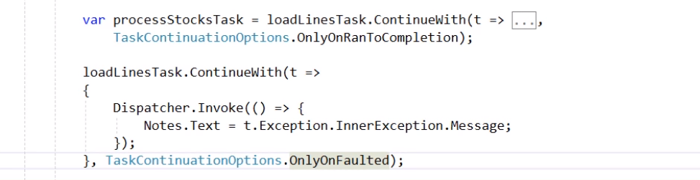





Cancel task